**Introduction**

Understanding the Earth's climate system involves comprehending the natural greenhouse effect, the radiation balance, and how human activities have enhanced this greenhouse effect, leading to global warming.

**Earth's Natural Greenhouse Effect**

The greenhouse effect is a natural process that warms the Earth’s surface. When the sun’s energy reaches the Earth, some of it is reflected back to space, and the rest is absorbed, warming the planet. The Earth then emits this energy as infrared radiation. Greenhouse gases in the atmosphere, including water vapor, carbon dioxide (CO₂), methane (CH₄), and nitrous oxide (N₂O), absorb and re-radiate this infrared radiation, trapping heat in the atmosphere and keeping the Earth’s surface warmer than it would be otherwise.

**Key Points:**

* The natural greenhouse effect is essential for life on Earth, maintaining an average surface temperature of about 15°C (59°F).
* Without this effect, the Earth's average surface temperature would be about -18°C (0°F), too cold to support most life forms.

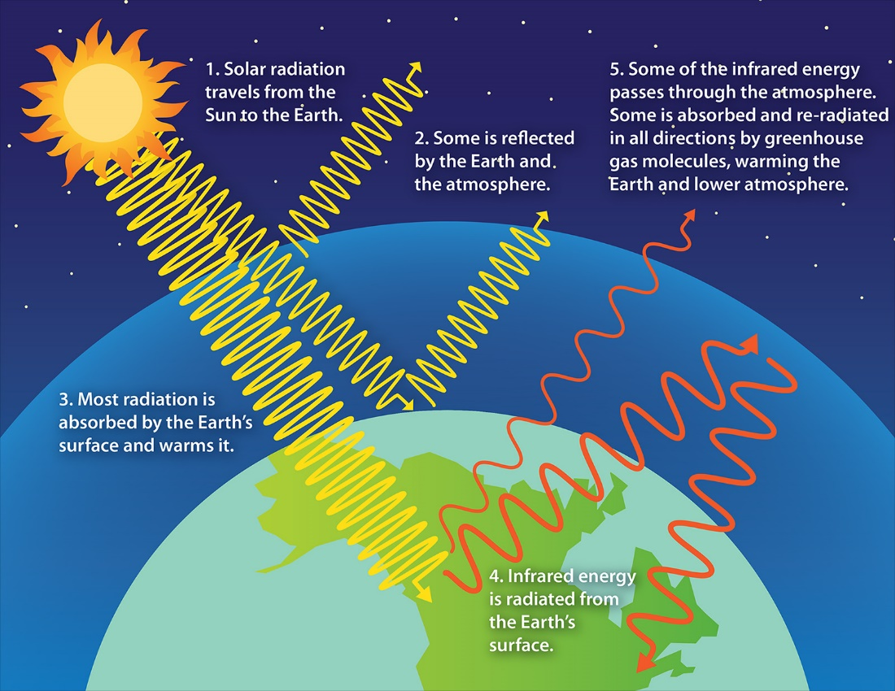

**Figure:** Green House Effect

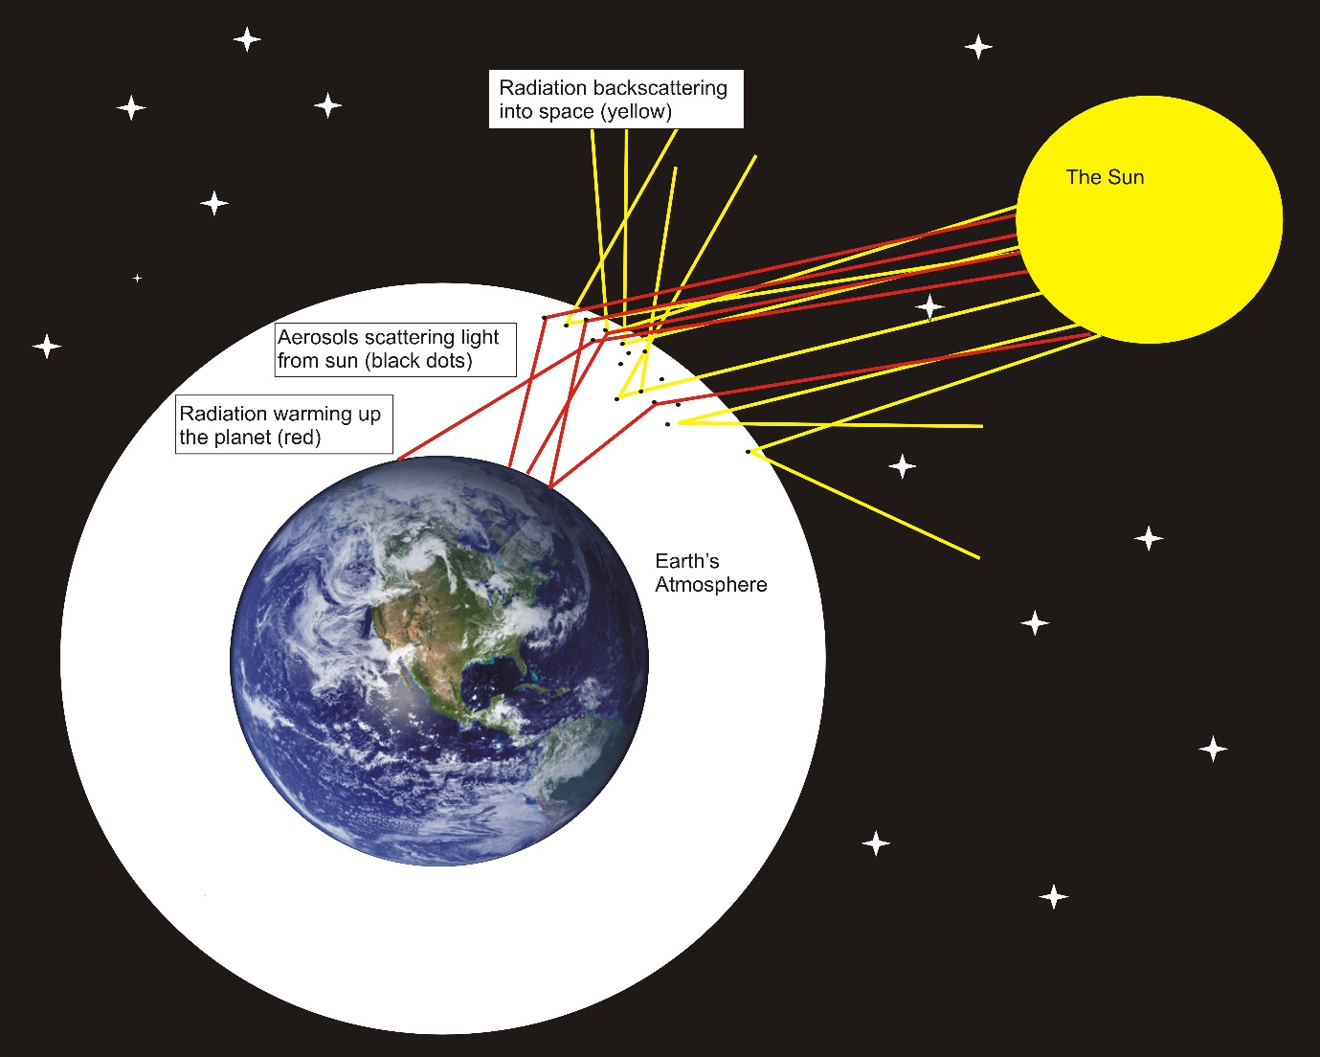

**Figure:** Radiation Balance

**Radiation Balance**

The Earth’s climate is determined by the balance between incoming solar radiation and outgoing infrared radiation. This balance is known as the Earth's radiation budget.

**Incoming Solar Radiation**

* **Solar radiation**: The sun emits energy in the form of visible light and ultraviolet radiation.
* **Reflection and absorption**: About 30% of the incoming solar radiation is reflected back to space by clouds, aerosols, and the Earth’s surface. The remaining 70% is absorbed by the Earth’s surface and atmosphere.

**Outgoing Infrared Radiation**

* **Re-radiation**: The Earth’s surface absorbs solar energy and then emits it as infrared radiation (heat).
* **Absorption by greenhouse gases**: Greenhouse gases absorb and re-radiate some of this infrared radiation back to the Earth's surface, trapping heat and maintaining the planet’s energy balance.

**Key Points:**

* The radiation balance is crucial for maintaining Earth’s climate stability.
* Any changes in the components of this balance can lead to climate change.

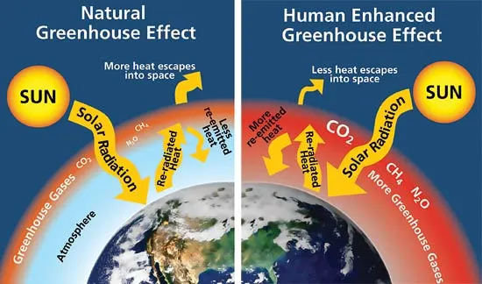

**Enhanced Greenhouse Effect**

The enhanced greenhouse effect refers to the additional warming caused by increased concentrations of greenhouse gases in the atmosphere due to human activities such as burning fossil fuels, deforestation, and industrial processes.

**Human Contributions**

* **Carbon dioxide (CO₂)**: Primarily from burning fossil fuels (coal, oil, natural gas) and deforestation.
* **Methane (CH₄)**: From agriculture (especially livestock), landfills, and natural gas production.
* **Nitrous oxide (N₂O)**: From agricultural practices and industrial activities.
* **Fluorinated gases**: Synthetic gases used in various industrial applications.

**Key Points:**

* The concentration of CO₂ has increased by more than 40% since the pre-industrial era, from about 280 ppm to over 415 ppm today.
* Methane and nitrous oxide concentrations have also significantly increased.
* This enhancement of the greenhouse effect leads to global warming, characterized by rising global temperatures, melting ice caps, rising sea levels, and changing weather patterns.

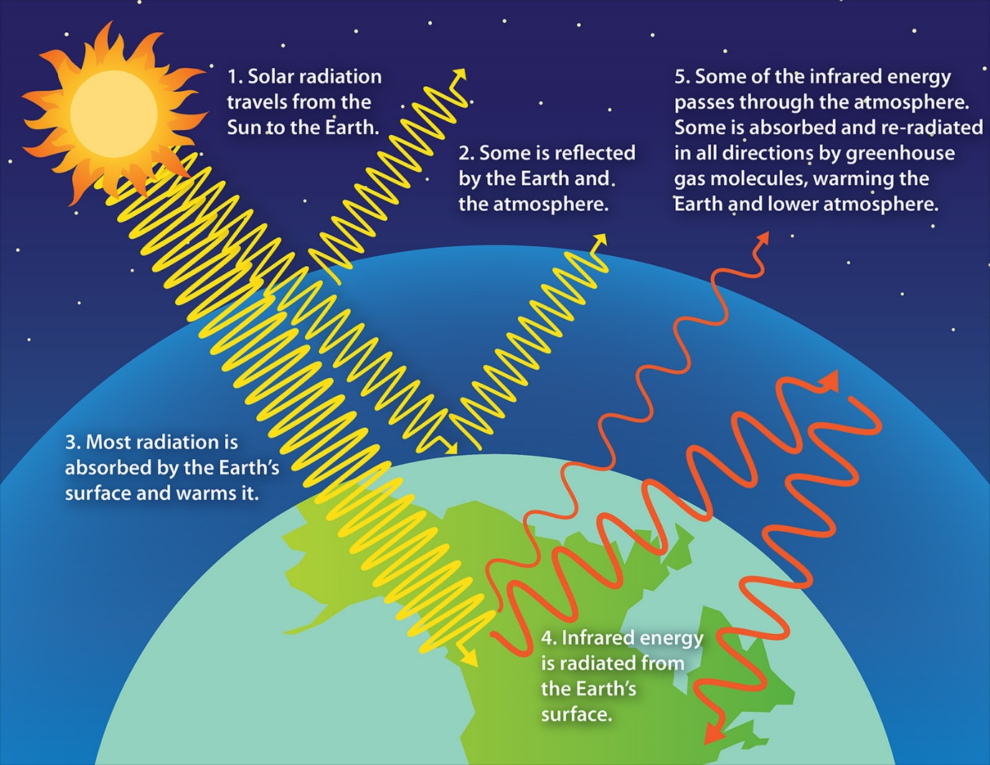

**Observed Impacts of the Enhanced Greenhouse Effect**

* **Temperature Rise**: Global average surface temperatures have increased by about 1.2°C since the late 19th century.
* **Ice Melt**: Glaciers and polar ice caps are melting, contributing to sea level rise.
* **Sea Level Rise**: Global sea levels have risen by about 20 cm over the past century.
* **Extreme Weather**: Increased frequency and intensity of extreme weather events such as heatwaves, heavy rainfall, and hurricanes.

**Summary Table**

| **Aspect** | **Description** | **Key Points** |
| --- | --- | --- |
| **Natural Greenhouse Effect** | The natural process where greenhouse gases trap heat in the atmosphere, keeping the Earth's surface warmer. | Essential for maintaining life-supporting temperatures on Earth. Without it, the average surface temperature would be about -18°C (0°F). |
| **Radiation Balance** | The balance between incoming solar radiation and outgoing infrared radiation. | Critical for climate stability. Any changes in this balance can lead to climate change. |
| **Enhanced Greenhouse Effect** | The additional warming caused by increased concentrations of greenhouse gases due to human activities. | Increased concentrations of CO₂, CH₄, and N₂O lead to global warming. Characterized by rising temperatures, melting ice caps, rising sea levels, and changing weather patterns. |
| **Human Contributions** | Activities like burning fossil fuels, deforestation, agriculture, and industrial processes increase greenhouse gas concentrations. | CO₂ from fossil fuels and deforestation; CH₄ from agriculture and natural gas production; N₂O from agriculture and industry; fluorinated gases from industrial applications. |
| **Observed Impacts** | The measurable effects of the enhanced greenhouse effect on the environment and climate. | Temperature rise, ice melt, sea level rise, and increased frequency and intensity of extreme weather events. |

**Conclusion**

Understanding the physical basis of climate change involves grasping how the natural greenhouse effect works, how the Earth’s radiation balance is maintained, and how human activities have enhanced the greenhouse effect, leading to global warming. This knowledge is crucial for developing strategies to mitigate and adapt to the impacts of climate change.