**The Physical Basis of Climate Change**

**Introduction**

Climate change refers to long-term alterations in temperature, precipitation, and other atmospheric conditions on Earth. These changes are driven by both natural processes and human activities. Understanding the physical basis of climate change involves examining how energy from the sun interacts with the Earth’s atmosphere, land, and oceans, and how this balance is affected by various factors.

**Energy Balance and the Greenhouse Effect**

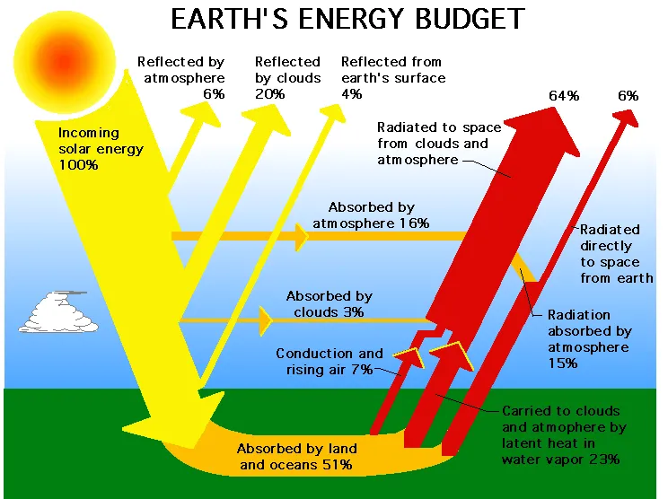The Earth's climate system is driven by energy from the sun. About 30% of the incoming solar radiation is reflected back into space by clouds, atmospheric particles, and bright ground surfaces like ice and snow. The remaining 70% is absorbed by the Earth’s surface and atmosphere, warming the planet.

The absorbed energy is then re-emitted as infrared radiation (heat). However, not all of this heat escapes directly into space. Greenhouse gases (GHGs) like carbon dioxide (CO₂), methane (CH₄), nitrous oxide (N₂O), and water vapor absorb and re-radiate some of this infrared radiation back towards the Earth's surface, effectively trapping heat. This process is known as the greenhouse effect and is crucial for maintaining the planet’s temperature at a level suitable for life.

**Key Greenhouse Gases**

**Carbon Dioxide (CO₂)**

CO₂ is the most significant greenhouse gas released by human activities, primarily through the burning of fossil fuels (coal, oil, and natural gas) and deforestation. The concentration of CO₂ in the atmosphere has increased by more than 40% since the industrial revolution.

**Methane (CH₄)**

Methane is a potent greenhouse gas with a global warming potential many times greater than CO₂, but it exists in smaller concentrations. Major sources include livestock digestion, rice cultivation, landfills, and the production and transport of fossil fuels.

**Nitrous Oxide (N₂O)**

N₂O is emitted from agricultural and industrial activities, as well as during the combustion of fossil fuels and solid waste. It has a significant warming effect and also contributes to the depletion of the ozone layer.

**Radiative Forcing**

Radiative forcing is a measure of the influence of a particular factor (such as GHGs, aerosols, or land use changes) on the energy balance of the Earth’s atmosphere system. Positive radiative forcing leads to warming, while negative radiative forcing leads to cooling.

**Feedback Mechanisms**

Climate feedbacks are processes that can either amplify or dampen the effects of climate forcings. Key feedback mechanisms include:

**Water Vapor Feedback**

As temperatures rise, more water evaporates, increasing the concentration of water vapor (a powerful greenhouse gas) in the atmosphere, which in turn leads to further warming.

**Ice-Albedo Feedback**

Ice and snow have high reflectivity (albedo). As they melt due to rising temperatures, darker surfaces (ocean or land) are exposed, which absorb more solar radiation, leading to further warming and more ice melt.

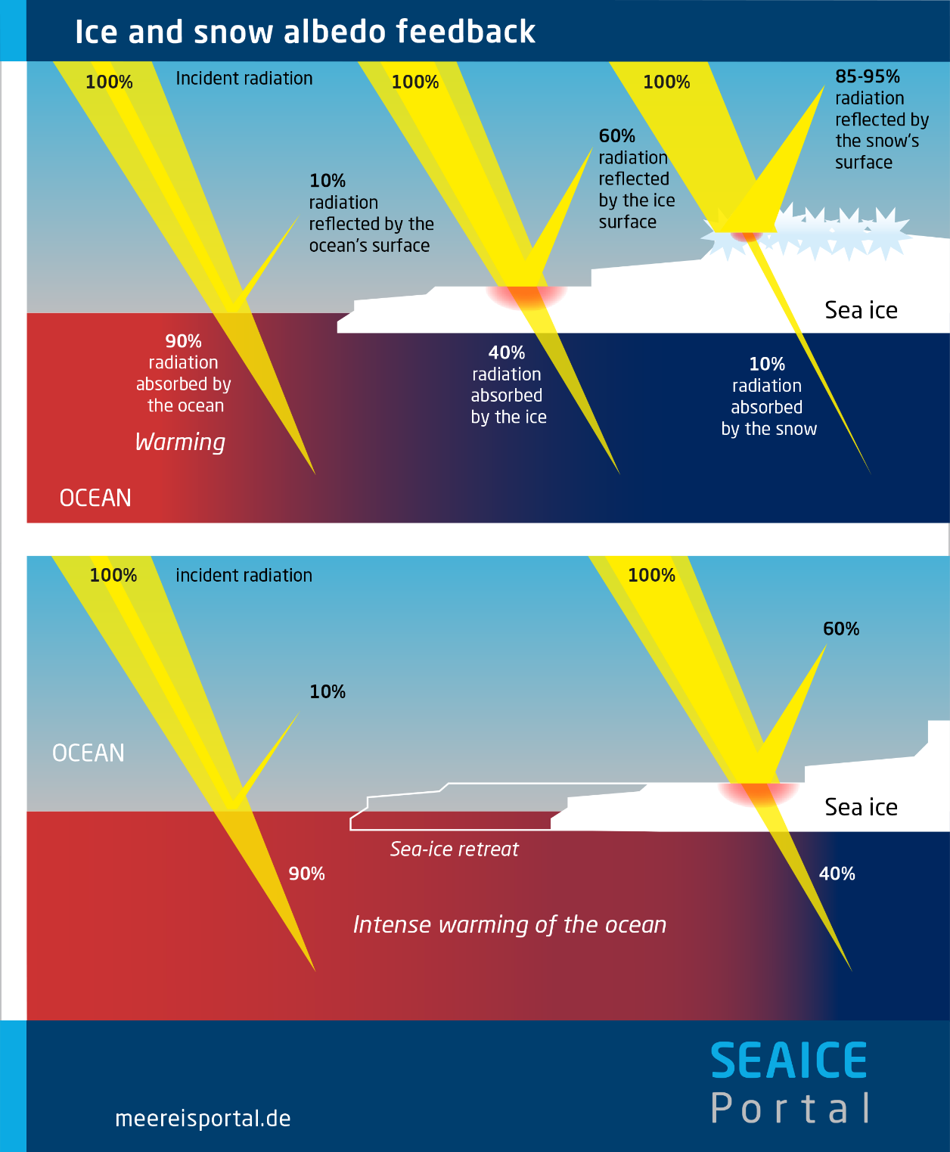

**Cloud Feedback**

Clouds can both cool the Earth by reflecting sunlight and warm it by trapping heat. Changes in cloud cover and type in response to warming can thus have complex effects on the climate.

**Ocean Circulation and Heat Distribution**

The world’s oceans play a critical role in regulating climate by storing and transporting heat and carbon. Ocean currents distribute heat around the globe, influencing regional climates. For example, the Gulf Stream transports warm water from the tropics to the North Atlantic, affecting the climate of Europe.

**Observed Changes and Evidence**

Evidence of climate change is seen in a variety of physical and biological indicators:

**Temperature Increase**

Global average surface temperatures have risen by about 1.2°C (2.2°F) since the late 19th century, with the most recent decades being the warmest in the instrumental record.

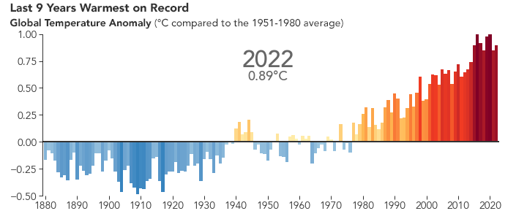

**Melting Ice and Snow**

Glaciers and ice sheets in Greenland and Antarctica are losing mass, contributing to sea level rise. Arctic sea ice extent has declined dramatically, particularly in summer.

**Sea Level Rise**

Global sea levels have risen by about 20 cm (8 inches) over the past century, primarily due to the thermal expansion of seawater as it warms and the addition of meltwater from glaciers and ice sheets.

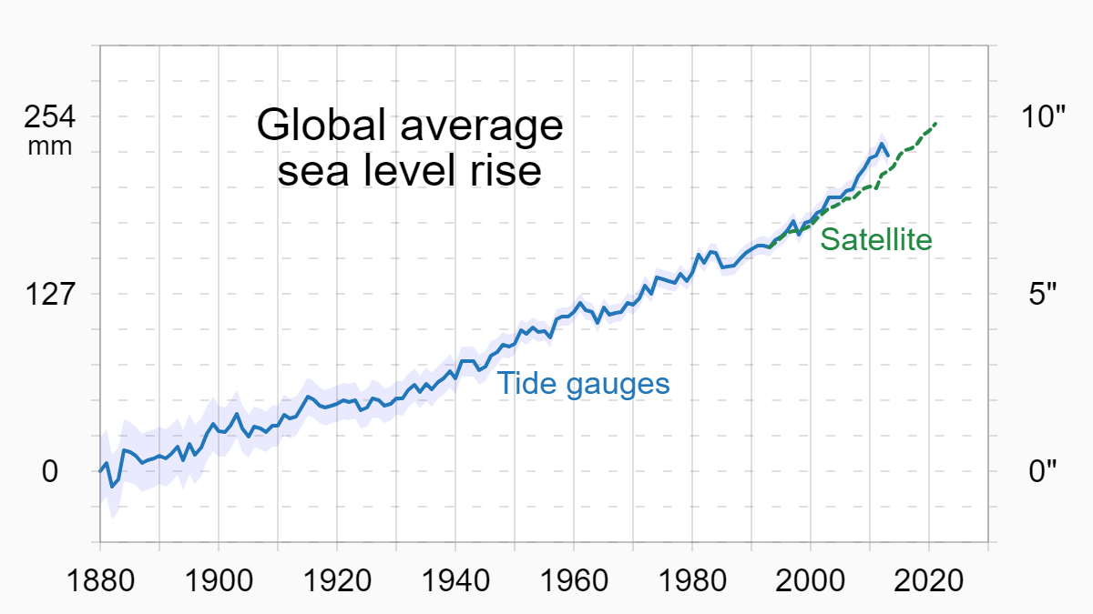

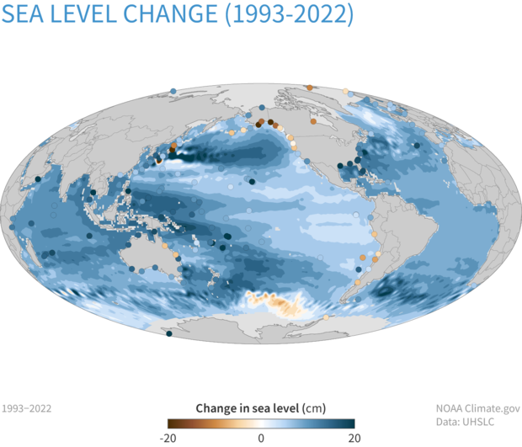

**Changes in Weather Patterns**

Increased frequency and intensity of extreme weather events such as heatwaves, heavy rainfall, and hurricanes have been linked to climate change.

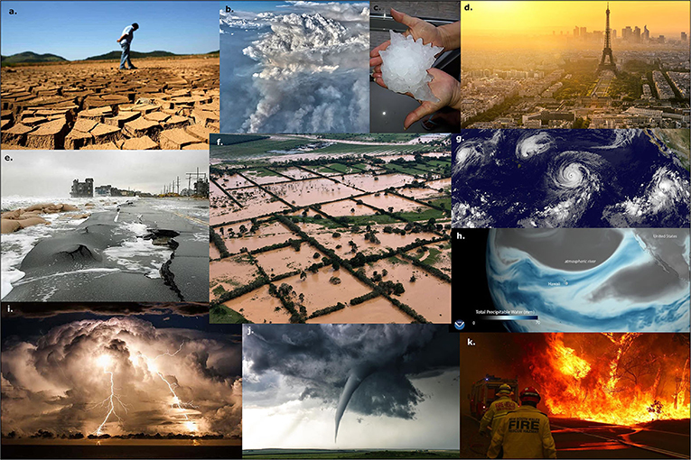

The physical basis of climate change is grounded in well-established scientific principles. The enhanced greenhouse effect due to increased concentrations of greenhouse gases is the primary driver of recent climate change. Observations of temperature increases, melting ice, rising sea levels, and changing weather patterns provide compelling evidence that the Earth's climate is warming. Understanding these physical processes is crucial for predicting future changes and developing strategies to mitigate and adapt to the impacts of climate change.