**Overview of the Nairobi work programme**

Objective:

The Nairobi work programme (NWP) strives to assist all Parties, in particular developing countries, including the least developed countries and small island developing states, to improve their understanding and assessment of impacts, vulnerability and adaptation, and to make informed decisions on practical adaptation actions and measures to respond to climate change on a sound, scientific, technical and socioeconomic basis, taking into account current and future climate change and variability.

The NWP responds to knowledge needs identified by Parties and those arising from the implementation of the Cancun adaptation framework as well as other relevant workstreams and bodies under the Convention.

Upon its adoption in 2005, the objectives, expected outcomes, scope of work, and modalities of the Nairobi work programme were defined in Decision 2/CP.11. Subsequent decisions and conclusions have extended the programme and further elaborated its areas of work.

**Work areas and modalities at a glance**

The NWP is structured around several work areas, issues, and modalities (means of implementation). These are consistent with Decision 2/CP.11, Decision 17/CP.19 and subsequent mandates. They include:

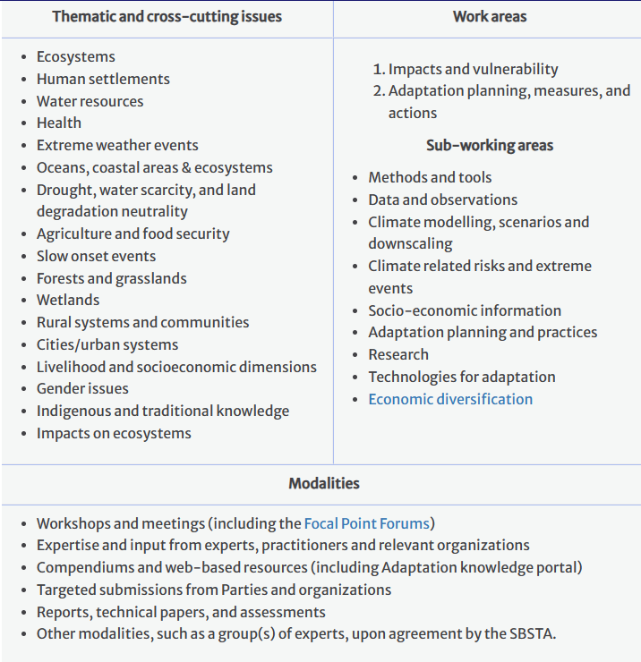

**Expected Outcomes**

The expected outcomes of the programme of work are:

Enhanced capacity at local, sectoral, national, regional, and international levels to further identify and understand impacts, vulnerability, and adaptation responses, and to select and implement practical, effective and high priority adaptation actions;

Improved information and advice to the Conference of the Parties (COP) and its subsidiary bodies on the scientific, technical and socio-economic aspects of impacts, vulnerability and adaptation;

Enhanced development, dissemination and use of knowledge from practical adaptation activities;

Enhanced cooperation among Parties, relevant organizations, business, civil society and decision makers, aimed at enhancing their ability to manage climate change risks;

Enhanced integration of actions to adapt to climate change with sustainable development.