**Instructor Name: Dr. Shashikala Gurpur and Dr. Sujata Arya**

**Activity: IRAC Analysis: Daniel Billy and Others v. Australia (2022)**

**Activity Title**: IRAC Analysis

* **Introduction**: This activity assesses your case analysis skills with regards to climate change litigation.
* **Objectives:**
* 1) To familiarize participants with the IRAC (Issue, Rule, Analysis, Conclusion) method of legal analysis.
* 2) To apply the IRAC method specifically to cases related to climate change litigation, thereby enhancing comprehension of legal principles in this domain.
* 3) To cultivate critical thinking skills by identifying legal issues, applying relevant laws, analyzing arguments, and formulating conclusions within the context of climate change litigation.
* **Instructions:**
* 1) Each participant will read through the case of Daniel Billy and Others v. Australia (2022). Ensure that the case provides sufficient legal complexity to facilitate comprehensive IRAC analysis.
* 2) Judgment of the case will be provided.
* 3) Evaluate how the law should be interpreted and applied in the given context. Consider relevant precedents, legal principles, and arguments presented by both parties.

By completing the above-mentioned activity, participants will achieve a deeper understanding of legal analysis methodologies, particularly the IRAC method, as applied to climate change litigation, fostering critical thinking, effective communication, and problem-solving skills within this specialized legal domain.

**Warm-up Activity:**

Try to elaborate on what the pictures are describing.

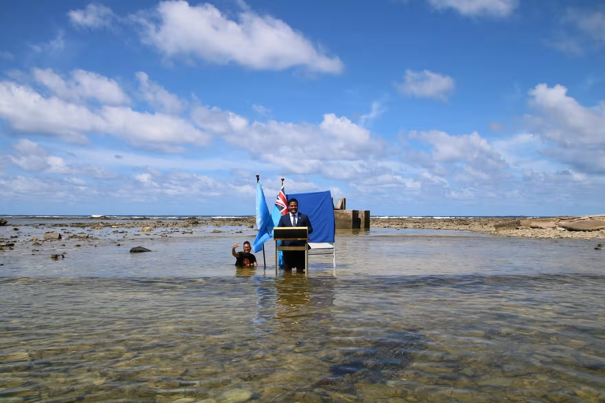

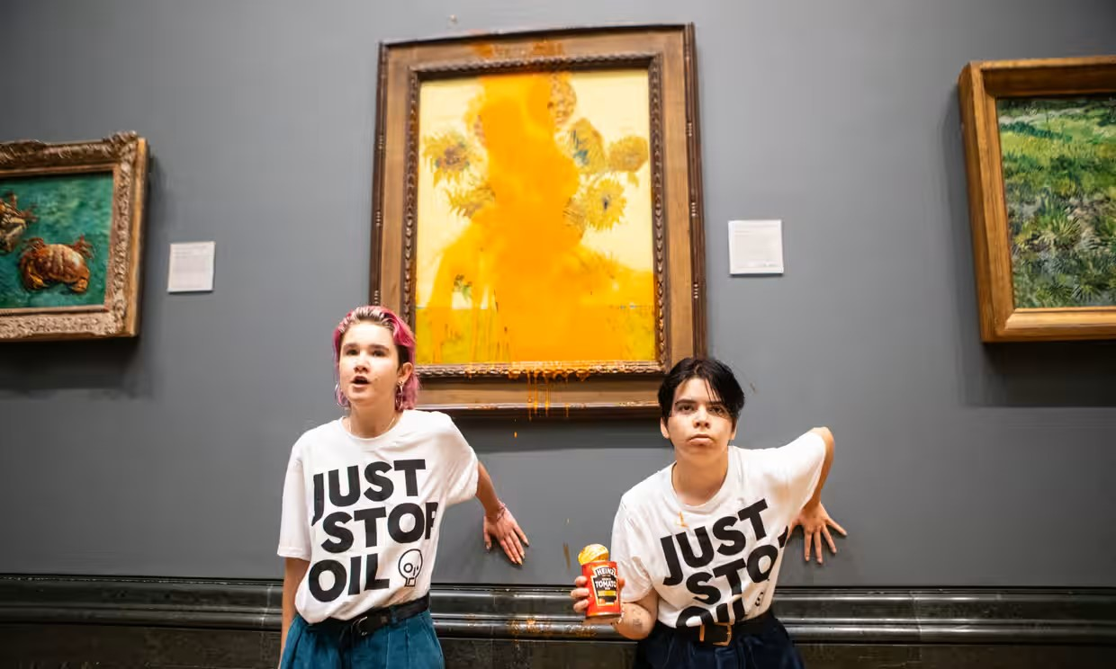

Photograph 1: Photograph: John Sibley/Reuters

Queen’s Guard is given a sip of water during the record-breaking heatwave, London, July 2022, John SiMight the record temperatures in the UK this summer be the wake-up call we need? A reading of 40.3C was recorded in the Lincolnshire village of Coningsby on 19 July. This is startling for a country renowned for its temperate maritime (read: soggy) climate.

Photograph 2: Photograph: Antonio Olmos/The Guardian

Two protesters threw soup at Vincent Van Gogh’s famous 1888 work Sunflowers at the National Gallery in London. They caused no damage to the glass-covered painting

Photograph 3: Photograph: Tuvalu Ministry of Justice, Communication and Foreign Affairs/Reuters

In one of the most memorable moments of last November’s Cop26, the foreign minister of Tuvalu, an island nation in the south Pacific, addressed a speech to the summit while knee-deep in the Pacific. “Climate change and sea level rise are deadly and existential threats to Tuvalu and low-lying atoll countries,” Simon Kofe said. “We are sinking.