**Solar Energy**

Why is daytime brighter and warmer than nighttime? The answer is simple: solar energy. Solar energy is simply the light and heat that come from the sun.

People can harness the sun's energy in a few different ways:

* **Photovoltaic cells,** which convert sunlight into electricity.
* **Solar thermal technology,** where heat from the sun is used to make hot water or steam.
* **Passive solar heating,** which can be as simple as letting the sun shine through windows to heat the inside of a building.

## Photovoltaic Cells

Do you have a solar calculator or watch? These items are powered by photovoltaic cells. A photovoltaic cell absorbs light and converts it directly into electricity. A group of photovoltaic cells is known as a solar panel.

You may have seen solar panels on houses, on electronic road signs, or in parking lots to power lights. People who have solar panels on their homes buy less electricity from their utility companies because they're producing some electricity on their own. If you have enough solar panels, you might even be able to generate more power than you need. In some states, this means you can run your electric meter backwards and give your extra electricity to the rest of the community. The electric company ends up paying you!

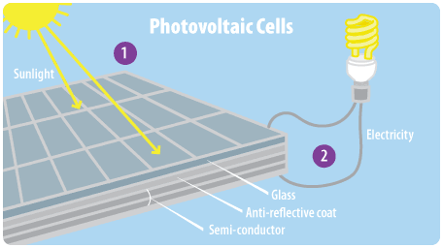

## Solar Thermal Technology

Another way to tap solar energy is by collecting the sun's heat. Solar thermal power plants use heat from the sun to create steam, which can then be used to make electricity. On a smaller scale, solar panels that harness thermal energy can be used for heating water in homes, other buildings, and swimming pools.

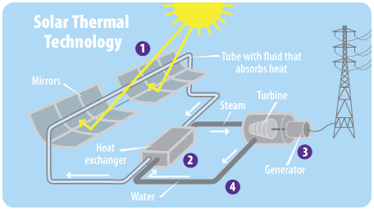

## Passive Solar Heating

Have you ever noticed how sunlight streaming through a window can make your home feel warmer, even on a cold day? If so, you've seen passive solar heating in action! People can design or remodel buildings to take advantage of heat from the sun during the winter. It helps to have large windows that face south (the side that gets the most sunlight everywhere north of the Equator) and are not shaded by other buildings or trees. A good design often includes overhangs, movable awnings, or blinds that block the sun during the summer when people need to cool their homes instead of heating them.

# Wind Energy

The wind can blow your hat off, rustle the trees, and even power your television. For thousands of years, people have used windmills to grind grain and pump water. Today, modern machines called wind turbines are used to make electricity. To produce a lot of electricity, many wind turbines can be placed together on wind farms. Good sites for wind farms are often found on windy hilltops, open plains, and shorelines.

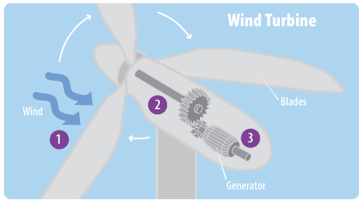

# Water Energy

If you've ever stood in a fast–moving stream, under a waterfall, or on the ocean shore as waves come crashing in, then you've felt the power of the water. The energy from moving water can be used to create electricity in several different ways. For example:

* **A hydroelectric dam** captures energy from the movement of a river. Dam operators control the flow of water and the amount of electricity produced. Dams create reservoirs (large bodies of calm water) behind them, which can be used for recreation, wildlife sanctuaries, and sources of drinking water.
* **Wave power** captures energy from waves on the surface of the ocean using a special buoy or other floating device.
* **Tidal power** captures the energy of flowing waters with the help of turbines as tides rush in and out of coastal areas.

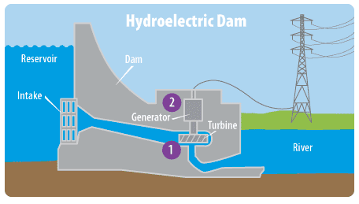

# Nuclear Energy

Atoms are tiny particles that make up every object in the universe. The bonds that hold atoms together contain a huge amount of energy. When atoms are split apart, this energy can be used to make electricity. This process is called nuclear fission.

In a nuclear power plant, fission takes place inside a reactor. Most nuclear power plants use uranium as fuel because its atoms are easily split apart. Uranium is a metal found in rocks all over the world. Although uranium is not a renewable resource, fairly large quantities of it still exist, and it only takes a small amount to produce a lot of energy.

Because nuclear power plants don't burn fossil fuels, they don't produce greenhouse gases. But mining and refining uranium requires large amounts of energy. In addition, nuclear power plants produce waste that is radioactive. This waste has to be handled and disposed of according to special regulations designed to protect people and the environment.

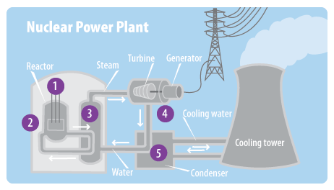

• In a nuclear reactor, fuel rods full of uranium pellets are placed in water.

• Inside the fuel rods, uranium atoms split, releasing energy.

• This energy heats water, creating steam.

• The steam moves through a turbine, which turns a generator to create electricity.

• The steam cools back into water, which can then be used over again. At some nuclear power plants, extra heat is released from a cooling tower.

# Geothermal Energy

f you were to dig a big hole straight down into the Earth, you would notice the temperature getting warmer the deeper you go. That's because the inside of the Earth is full of heat. This heat is called geothermal energy.

People can capture geothermal energy through:

* **Geothermal power plants,** which use heat from deep inside the Earth to generate steam to make electricity.
* **Geothermal heat pumps,** which tap into heat close to the Earth's surface to heat water or provide heat for buildings.

## Geothermal Power Plants

At a geothermal power plant, wells are drilled 1 or 2 miles deep into the Earth to pump steam or hot water to the surface. You're most likely to find one of these power plants in an area that has a lot of hot springs, geysers, or volcanic activity, because these are places where the Earth is particularly hot just below the surface.

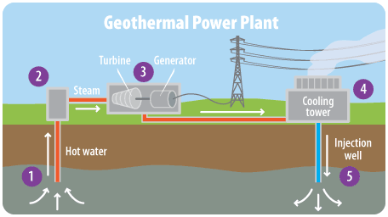

1. Hot water is pumped from deep underground through a well under high pressure.
2. When the water reaches the surface, the pressure is dropped, which causes the water to turn into steam.
3. The steam spins a turbine, which is connected to a generator that produces electricity.
4. The steam cools off in a cooling tower and condenses back to water.
5. The cooled water is pumped back into the Earth to begin the process again.

## Geothermal Heat Pumps

Not all geothermal energy comes from power plants. Geothermal heat pumps can do all sorts of things—from heating and cooling homes to warming swimming pools. These systems transfer heat by pumping water or a refrigerant (a special type of fluid) through pipes just below the Earth's surface, where the temperature is a constant 50 to 60°F.

During the winter, the water or refrigerant absorbs warmth from the Earth, and the pump brings this heat to the building above. In the summer, some heat pumps can run in reverse and help cool buildings.

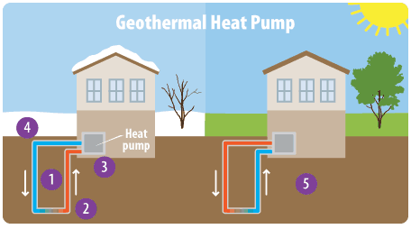

1. Water or a refrigerant moves through a loop of pipes.
2. When the weather is cold, the water or refrigerant heats up as it travels through the part of the loop that's buried underground.
3. Once it gets back above ground, the warmed water or refrigerant transfers heat into the building.
4. The water or refrigerant cools down after its heat is transferred. It is pumped back underground where it heats up once more, starting the process again.
5. On a hot day, the system can run in reverse. The water or refrigerant cools the building and then is pumped underground where extra heat is transferred to the ground around the pipes.

# Biomass Energy

Biomass is a fancy name for material from plants and animals. Some kinds of biomass can be burned to produce energy. One common example is wood.

Biomass contains stored energy. That's because plants absorb energy from the sun through the process of photosynthesis. When biomass is burned, this stored energy is released as heat.

Burning biomass releases carbon dioxide. However, plants also take carbon dioxide out of the atmosphere and use it to grow their leaves, flowers, branches, and stems. That same carbon dioxide is returned to the air when the plants are burned.

Many different kinds of biomass, such as wood chips, corn, and some types of garbage, are used to produce electricity. Some types of biomass can be converted into liquid fuels called biofuels that can power cars, trucks, and tractors. Leftover food products like vegetable oils and animal fats can create biodiesel, while corn, sugarcane, and other plants can be fermented to produce ethanol.

# Methane Capture and Use

You've probably heard about the [three R's](https://archive.epa.gov/climatechange/kids/solutions/actions/waste.html). While it's important to reduce, reuse, and recycle as much as you can, it's hard to avoid throwing out some trash every week. Trash that cannot be recycled or reused often ends up in landfills, where it produces methane as it decomposes.

Methane is a very powerful greenhouse gas. One pound of methane traps 25 times more heat in the atmosphere than a pound of carbon dioxide. Methane is also the main ingredient in natural gas. Because methane can be captured from landfills, it can be burned to produce electricity, heat buildings, or power garbage trucks. Capturing methane before it gets into the atmosphere also helps reduce the effects of climate change.

Methane can also be captured from farm digesters, which are big tanks that contain manure and other waste from barns that house livestock such as cows and pigs.

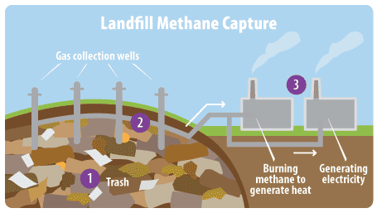

1. Trash decomposes (or rots) in landfills, creating methane gas.
2. Methane rises to the top of the landfill and is collected in pipes.
3. The methane is burned to produce heat or generate electricity.

# Carbon Capture and Underground Storage

Currently, most of our electricity is generated at large power plants that burn coal and other fossil fuels that add lots of carbon dioxide to the atmosphere. It will likely be many decades before we can get most of our electricity from renewable resources that emit little or no carbon dioxide. In the meantime, scientists are developing ways to capture carbon dioxide from power plants and factories and safely store it underground so that it can't go into the atmosphere.

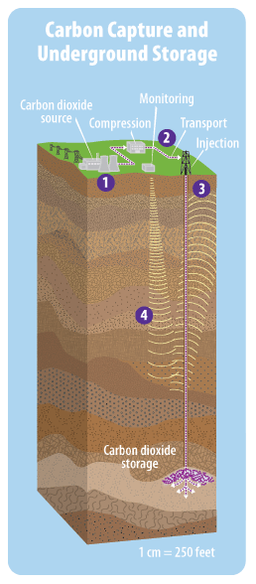

1. Carbon dioxide emissions from a power plant or factory are captured so they are not released into the atmosphere.
2. The captured carbon dioxide is sent through a pipeline to a place where underground rock formations can store the carbon dioxide safely and permanently.
3. The carbon dioxide is pumped deep underground (often more than half a mile down).
4. The site is monitored to make sure the stored carbon dioxide doesn't leak back up to the atmosphere or into underground sources of drinking water.

# Green Vehicles

How do you get to where you need to go? In the United States, vehicles that burn gasoline and diesel fuel are the main form of transportation for most people. Cars, trucks, buses, airplanes, trains, and other vehicles account for almost one–third of the energy consumed in the United States–and they also produce almost one–third of our greenhouse gas emissions.

While past generations were only able to buy gasoline–powered cars, you will have many more options! Vehicles are now available that use less energy and are better for the environment, and even more of these vehicles will be available in the future.

* **Fuel–efficient cars** use less gasoline than other cars to travel the same distance. When less gasoline is burned, less carbon dioxide ends up in the atmosphere.
* **Alternative fuel vehicles** run on fuels other than gasoline. Burning natural gas produces less carbon dioxide than gasoline or diesel, and burning hydrogen produces no carbon dioxide at all!
* **Flexible fuel vehicles** can run on gasoline, but they can also use a blend of up to 85 percent ethanol (a fuel produced from corn, sugar cane, or other types of [biomass](https://archive.epa.gov/climatechange/kids/solutions/technologies/biomass.html)) and 15 percent gasoline, known as E85. These cars have been produced since the 1980s.
* **Electric vehicles** are powered by an electric motor instead of a gasoline engine. From the outside, you might not be able to tell if a car is electric, but you'll see the difference if you look under the hood! Large batteries store energy to power the car, and you just plug it in to refuel. Electric vehicles emit no direct pollution, and if sources like wind and solar are used to generate the electricity, their total carbon dioxide emissions can be very small. You'll see more and more of these cars on the road in the years to come.
* **Hybrid–electric vehicles** combine the benefits of gasoline engines and electric motors. A hybrid car can go up to twice as far on a gallon of gasoline as a typical gasoline-powered car.

## Making Cars More Fuel–Efficient

You don't have to buy a new car to save energy!

**Select different parts of the car below for a few simple tips to help your family use less gasoline and reduce greenhouse gas emissions.**

# Energy–Efficient Buildings

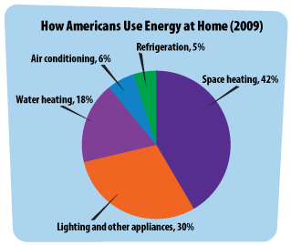

Every day, people flip on light switches, turn on their computers, and use energy in many other ways in their homes, offices, and schools. Using all that power leads to greenhouse gas emissions, especially if the energy is generated from fossil fuels. In fact, the buildings where we live and work account for 30 percent of all greenhouse gas emissions in the United States. Technologies such as more efficient heating, air conditioning, and lighting enable buildings to use less energy, which helps reduce greenhouse gas emissions. Learn more about energy efficiency at [ENERGY STAR](http://www.energystar.gov/).