**Instructor Name: Dr. Shashikala Gurpur and Dr. Sujata Arya**

**Activity: Picture Description**

**Activity Title**: Picture Description of Climate Justice

* **Introduction**: This activity assesses your knowledge of concepts and perspectives on Climate Justice.
* **Objectives:**
* 1. Assess understanding of climate change's unequal impacts on marginalized communities.
* 2. Evaluate awareness of the interconnectedness of climate, social justice, and economic inequality.
* 3. Test knowledge of solutions and actions for promoting climate justice.
* By completing this activity you will demonstrate your knowledge and understanding of climate justice, highlighting the interconnectedness of climate change with social justice and equity, and recognizing the challenges in achieving fairness and equality in addressing climate issues.

**Warm-up Activity:**

Try to elaborate on what the pictures are describing.

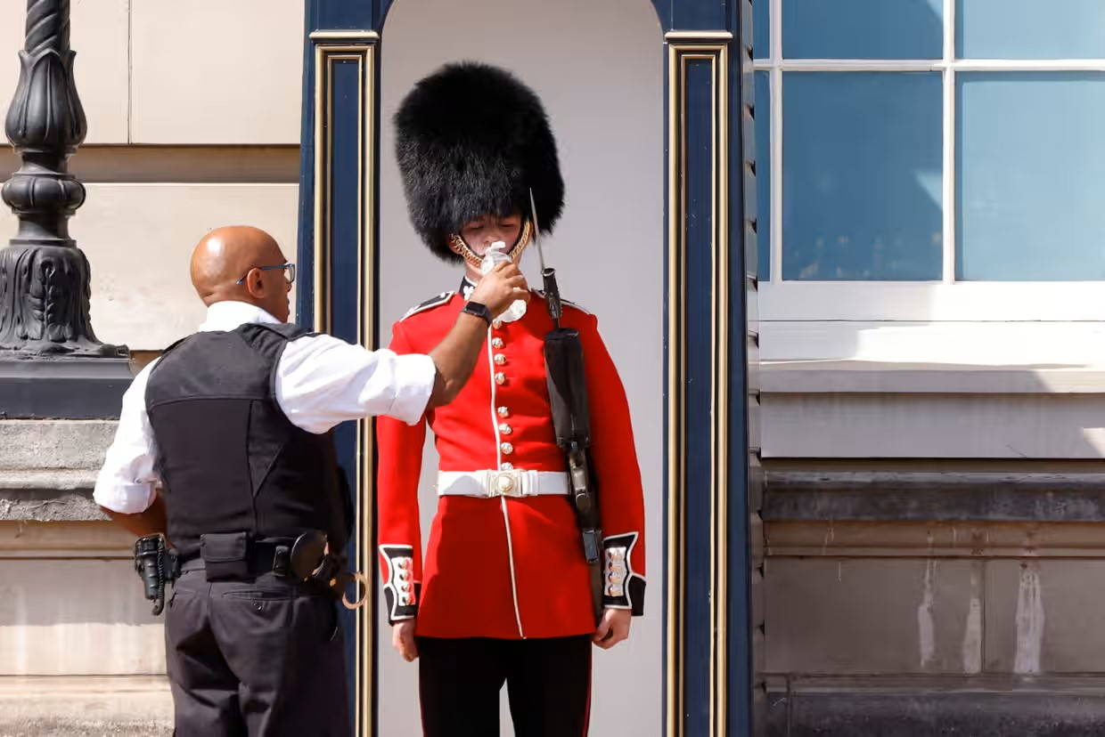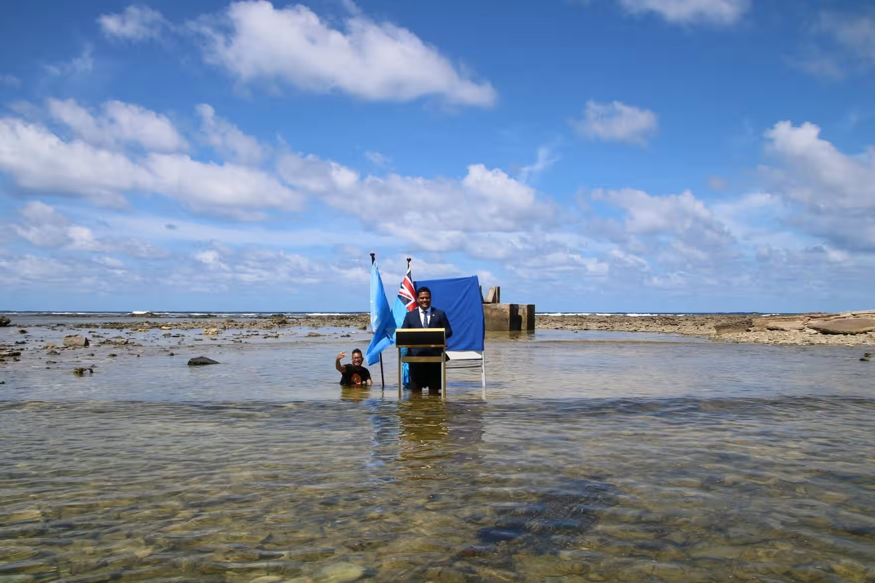

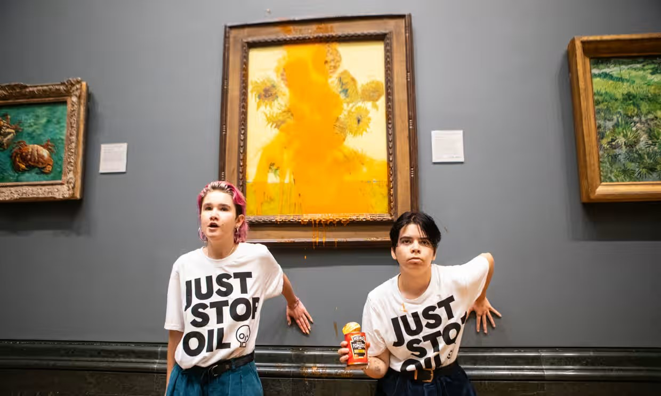

Photograph 1: Photograph: John Sibley/Reuters

Queen’s Guard is given a sip of water during the record-breaking heatwave, London, July 2022, John SiMight the record temperatures in the UK this summer be the wake-up call we need? A reading of 40.3C was recorded in the Lincolnshire village of Coningsby on 19 July. This is startling for a country renowned for its temperate maritime (read: soggy) climate.

Photograph 2: Photograph: Antonio Olmos/The Guardian

Two protesters threw soup at Vincent Van Gogh’s famous 1888 work Sunflowers at the National Gallery in London. They caused no damage to the glass-covered painting

Photograph 3: Photograph: Tuvalu Ministry of Justice, Communication and Foreign Affairs/Reuters

In one of the most memorable moments of last November’s Cop26, the foreign minister of Tuvalu, an island nation in the south Pacific, addressed a speech to the summit while knee-deep in the Pacific. “Climate change and sea level rise are deadly and existential threats to Tuvalu and low-lying atoll countries,” Simon Kofe said. “We are sinking.