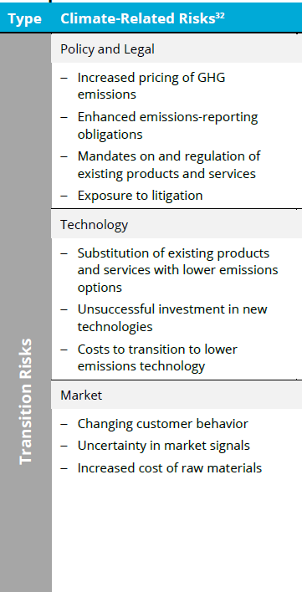

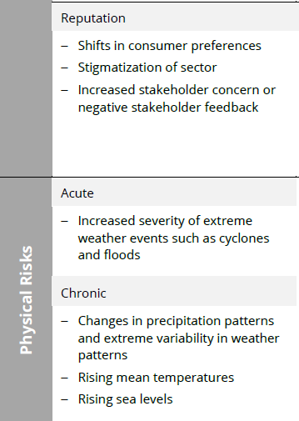

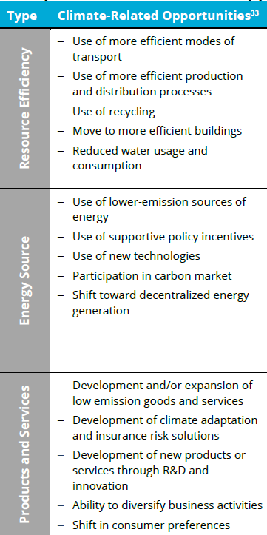

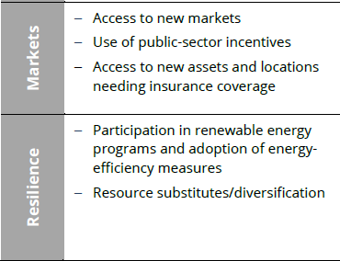

Sources:

**Final Report:** Recommendations of the Task Force on Climate-related Financial Disclosures by Task Force on Climate Related Financial Disclosure; June 2017