**THE NAIROBI WORK PROGRAMME**

The UNFCCC's Knowledge-To-Action Hub: Closing Knowledge Gaps to Advance

Transformative Adaptation and Resilience in a Changing Climate

THE PARIS AGREEMENT SHINES A GLOBAL SPOTLIGHT ON ADAPTATION

The landmark Paris Agreement charts a new course to combat climate change, with Parties agreeing to limit global temperature rise to well below 2 degrees Celsius and build resilience to intensifying impacts. Establishing the world’s first-ever global goal on adaptation, the 2015 accord elevates the political visibility of resilience and has helped catalyze ambitious adaptation action around the world. Many vulnerable countries are now adopting innovative strategies, from restoring coastal ecosystems that defend against storm surges to developing early warning systems that save lives during extreme weather events.

Yet, despite growing political will to build resilience to climate change, challenges realizing countries’ commitments under the Paris Agreement persist. Existing information on adaptation remains inaccessible in many of the world’s most vulnerable nations, and available data sets often fall short of meeting decision-makers’ needs. This mismatch in adaptation knowledge supply and demand impedes efforts to manage climate risks at regional, national and subnational levels. In the [Hindu Kush Himalayan region](https://www4.unfccc.int/sites/nwpstaging/Pages/LAKI_HKH.aspx), for example, a lack of actionable information has until recently undermined efforts to develop and implement early flood warning systems, while limited access to agricultural technologies and improved farming methods have frustrated efforts to bolster food security in [Southern Africa’s changing climate](https://www4.unfccc.int/sites/nwpstaging/Pages/LAKI-SouthernAfrica.aspx).

THE NAIROBI WORK PROGRAMME'S MISSION

Established by the Conference of Parties (COP) in 2005, the [Nairobi Work Programme (NWP)](https://unfccc.int/nwp) assists all Parties, in particular developing countries, including the Least Developed Countries (LDCs) and Small Island Developing States (SIDS), in (i) improving their understanding and assessment of climate change impacts, vulnerability and adaptation; and (ii) making informed decisions on practical adaptation actions and measures to respond to climate change on a sound scientific, technical and socioeconomic basis, taking into account current and future climate change and variability.

THE NAIROBI WORK PROGRAMME'S APPROACH

The NWP, the UNFCCC’s authoritative Knowledge-To-Action Hub, synthesizes the best available information on all aspects of vulnerability and adaptation, disseminates its findings widely and cultivates high-impact partnerships to close critical knowledge gaps and accelerate action around the world.

As the UNFCCC’s first inclusive stakeholder engagement mechanism fully responsive to both Parties and non-Party organizations, we start by understanding their unique adaptation and resilience knowledge needs.

Next, we convene leading technical experts from our more than [380 partner organizations](https://www4.unfccc.int/sites/NWPStaging/Pages/NWP-partner-organizations.aspx) to synthesize existing information and conduct additional research. They produce accessible knowledge products that decision-makers need to formulate and implement effective, evidence-based policies, such as National Adaptation Plans (NAPs). We not only share our partners’ [extensive body of work](https://www4.unfccc.int/sites/NWPStaging/Pages/OtherKnowledge.aspx) – case studies, synthesis reports, tools, methods and more – with key decision-makers, but we also make these findings publicly available on the NWP’s user-friendly [Adaptation Knowledge Portal](https://www4.unfccc.int/sites/nwpstaging/Pages/Home.aspx).

The NWP also cultivates high-impact partnerships between knowledge producers and users to close critical knowledge gaps, advance implementation of transformative adaptation approaches and maximize returns on resilience investments across a diverse set of [thematic areas](https://www4.unfccc.int/sites/NWPStaging/Pages/Thematic-areas.aspx) and in the context of the [Lima Adaptation Knowledge Initiative (LAKI)](https://www4.unfccc.int/sites/nwpstaging/Pages/laki.aspx).

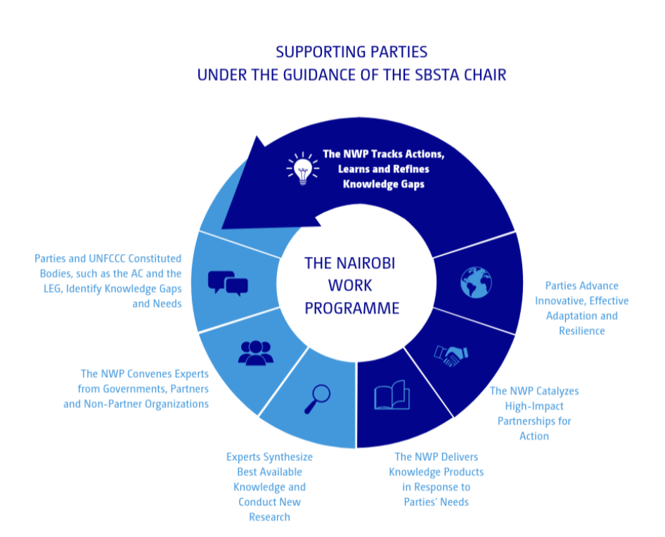

THE NAIROBI WORK PROGRAMME IN ACTION

The NWP directly responds to knowledge needs identified by Parties, particularly developing countries, who negotiated our [thematic areas of work](https://www4.unfccc.int/sites/NWPStaging/Pages/Thematic-areas.aspx) under the UNFCCC. We also provide technical assistance to constituted bodies under the Convention, including the Adaptation Committee (AC) and the Least Developed Countries Expert Group (LEG). For example, in collaboration with the LEG, we have supported many of the world’s LDCs formulate and implement NAPs that strengthen the resilience of vulnerable communities, groups and ecosystems. Together with the LEG, we are mobilizing inputs from our partners for effective implementation by publishing guidelines for Parties, co-organizing technical sessions like "[Assessing progress in adaptation in vulnerable groups, communities and ecosystems](http://napexpo.org/2019/sessions/parallel-session-7-2/)," and developing indicators to evaluate progress of adaptation moving forward.

Engaging with the NWP’s diverse network of government officials, practitioners and experts at the 2019 NAP Expo technical session co-organized by the NWP and the LEG afforded me a unique opportunity to gain critical insights on building vulnerable communities’ resilience and adopting effective ecosystem-based adaptation approaches. Lessons learned from the challenges and successes that my colleagues have faced in similar regions around the world have proven instrumental in my work as part of the team formulating Nigeria’s NAP. Many of the obstacles that vulnerable communities in my country face mirror those that NWP’s partners are addressing, and I plan, as part of the team, to implement comparable solutions."- Adebayo Abel Adekoje, Desk Officer, National Adaptation Plan Department of Climate Change, Federal Ministry of Environment, Nigeria.

Our Thematic Areas

Critical knowledge gaps center around the following [thematic areas](https://www4.unfccc.int/sites/NWPStaging/Pages/Thematic-areas.aspx), identified by Parties to the UNFCCC:

Agriculture and food security

[Ecosystems](https://www4.unfccc.int/sites/NWPStaging/Pages/ecosystems-page.aspx), [water](https://www4.unfccc.int/sites/NWPStaging/Pages/ecosystems-page.aspx), wetlands, forests and grasslands

Drought, water scarcity and land degradation neutrality

Oceans, coastal areas and ecosystems, including mega deltas, coral reefs and mangroves

Slow onset events

Extreme weather events, such as heat waves, flash floods, sand and dust storms, cyclones and heavy precipitation

Economic diversification

Livelihood and socioeconomic dimensions in relevant sectors, such as tourism

[Health](https://www4.unfccc.int/sites/NWPStaging/Pages/Health-page.aspx)

[Human settlements](https://www4.unfccc.int/sites/NWPStaging/Pages/HS-page.aspx), cities and urban systems

Rural systems and communities

Indicators of climate adaptation and resilience

On human settlements, for example, the NWP facilitated a partnership between the United Nations Human Settlements Program (UN-Habitat) and the LEG to develop accessible, [policy-relevant guidelines](https://fr.unhabitat.org/wp-content/uploads/2019/01/Addressing-urban-human-setlements-issues-in-NAPs-web.pdf) that Parties are using to integrate human settlement challenges and solutions across national adaptation planning and implementation.

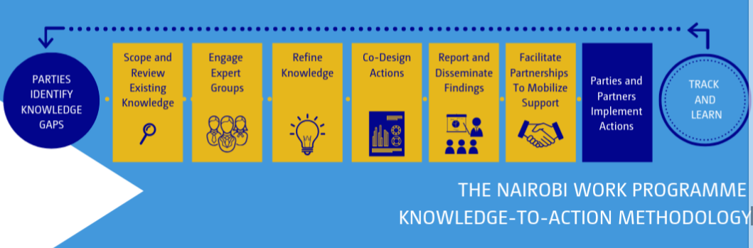

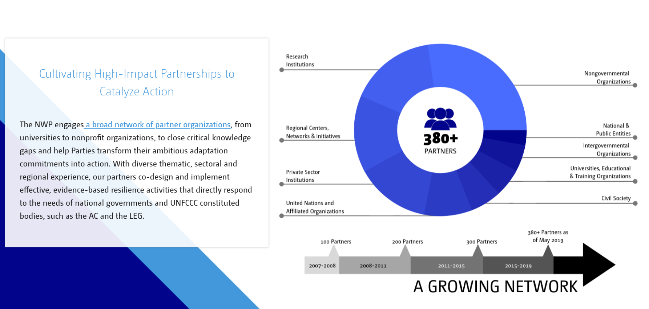

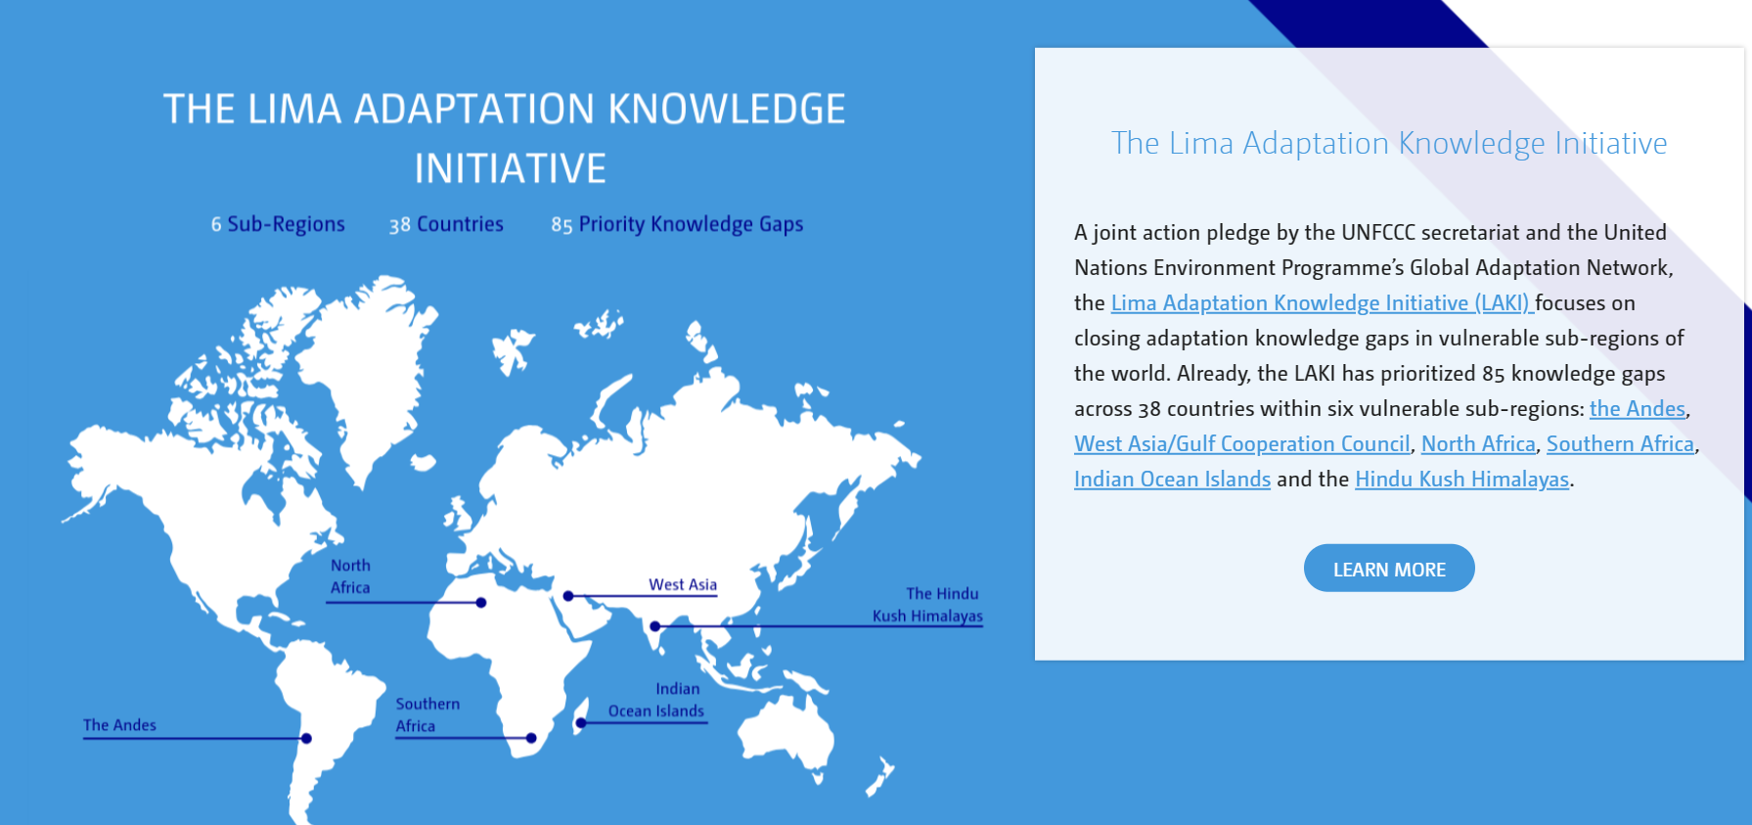

The LAKI's Successes and Moving Forward

Already, the LAKI has proved an invaluable initiative in many countries. In the Indian Ocean Islands sub-region, graduate students from the University of Michigan School for Environment and Sustainability partnered with local experts at the University of Seychelles’ James Michel Blue Economy Research Institute to evaluate sea level rise and storm surge impacts on Seychelles’ critical infrastructure. Their [easily accessible report](https://umich.maps.arcgis.com/apps/MapSeries/index.html?appid=529d197fc7374f9b9fcc40c6106baa6d) has informed local decision-making, and its outcomes will also benefit other Indian Ocean island countries, such as Comoros, the Maldives and Mauritius.

The LAKI will continue to scale up similar high-impact partnerships in new sub-regions, particularly in vulnerable developing countries such as the LDCs, SIDS and African states. As the initiative expands, we will also focus on sharing new knowledge, connecting adaptation experts, institutions and networks to catalyze action that closes knowledge gaps, and convening high-level partnerships to bring resources and technical know-how to vulnerable countries around the world.